Winter Day and J D U
Saturday February 18, 2023
Come and enjoy a fun filled day of
Winter Activities
Start off with JDU- location TBD
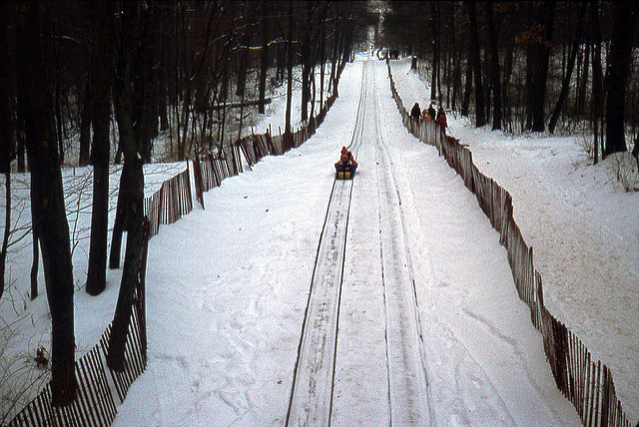
This Photo by Unknown Author is licensed under CC BY-SA-NC
Followed by Tobogganing
Chalet in Strongsville**
16200 Valley Parkway
Strongsville, OH 44136
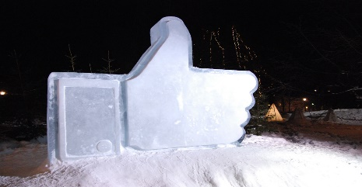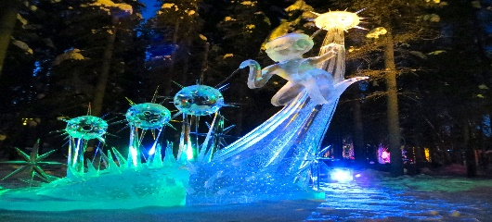
This Photo by Unknown Author is licensed under CC BY-SA-NC
This Photo by Unknown Author is licensed under CC BY-SA
Then finish off the night at the Medina Frozen Art show at the square in historic Medina

If you don’t want to toboggan, there is a nice chalet with a fire pit to warm yourself.
**You have to climb a lot of steps to get to the top of the Toboggan Chute*
*Gloves/mittens MUST be worn – no exceptions-Chalet’s rules**

We will be outside so dress for the weather. You may want to pack extra clothes so you will have dry clothes.
If the wind chill is horrible, & we have a change of event, we will let you know via the social media pages

REGISTRATION must be received by 2/2/2023

Make Checks payable to the
Grand Guardian Council of Ohio
Mail Check & Registration form to:
Brittany King
96 Tarryton Ct E
Columbus, OH 43228

REGISTRATION FORM
Name | $20 - Yes Toboggan | $10 - No Toboggan | DIETARY  RESTRICTIONS
Please make sure chaperone has & brings
Emergency Medical & Media Release forms for
All chaperones must be CAV approved

